|  |
| --- |
|  |
| The Documentation |
| [Type the document subtitle] |
|  |
| **[Your Name]** |
| **[Pick the date]** |

[Type the abstract of the document here. The abstract is typically a short summary of the contents of the document. Type the abstract of the document here. The abstract is typically a short summary of the contents of the document.]

Table of Contents

[To update the table of contents, right click the message below and select Update Field (F9 on PC, ⌥⌘U on Mac).]

**No table of contents entries found.**

1. Pages
   1. Page Tree

DCG TLP Requirements  
 Flow Diagram  
 Data Requirements  
 Business Rules/Roles  
 Org Architecture Reference  
Login  
Manager Home Page  
Business Group Admin Home Page  
Supergroup Admin Home Page  
Intel Level Admin Home Page

* 1. DCG TLP Requirements
     1. User Interface

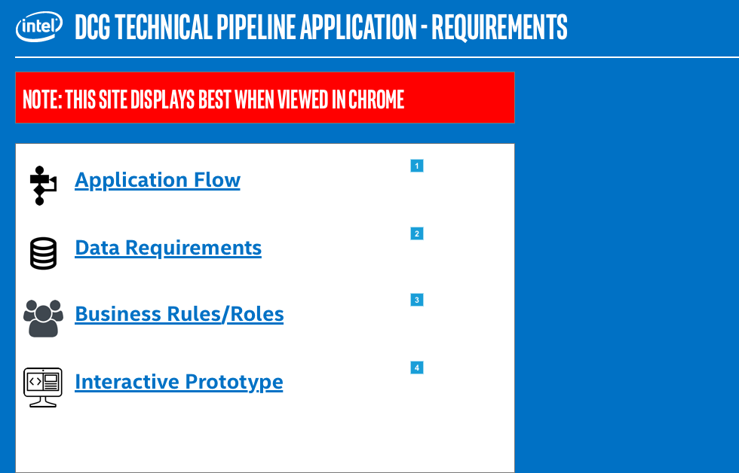

* + 1. Widget Table

| Footnote | Interactions |
| --- | --- |
| 1 | OnClick:  Case 1:  Open Flow Diagram in Current Window |
| 2 | OnClick:  Case 1:  Open Data Requirements in Current Window |
| 3 | OnClick:  Case 1:  Open Business Rules/Roles in Current Window |
| 4 | OnClick:  Case 1:  Open Login in Current Window |

* 1. Flow Diagram
     1. User Interface

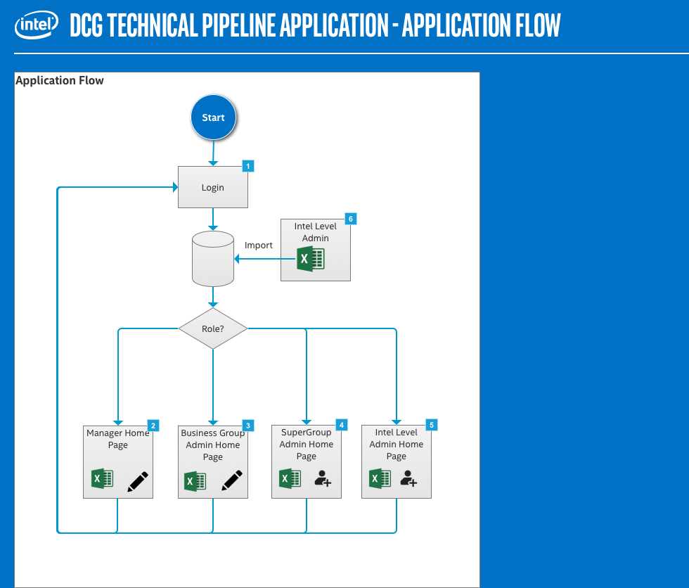

* + 1. Widget Table

| Footnote | Interactions |
| --- | --- |
| 1 | OnClick:  Case 1:  Open Login in Current Window |
| 2 | OnClick:  Case 1:  Open Manager Home Page in Current Window |
| 3 | OnClick:  Case 1:  Open Business Group Admin Home Page in Current Window |
| 4 | OnClick:  Case 1:  Open Supergroup Admin Home Page in Current Window |
| 5 | OnClick:  Case 1:  Open Intel Level Admin Home Page in Current Window |
| 6 | OnClick:  Case 1:  Open Intel Level Admin Home Page in Current Window |

* 1. Data Requirements
     1. User Interface

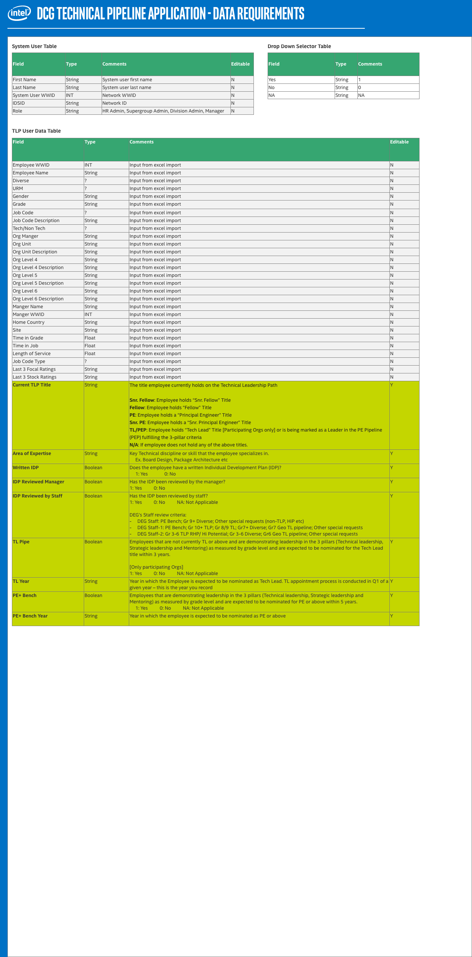

* 1. Business Rules/Roles
     1. User Interface

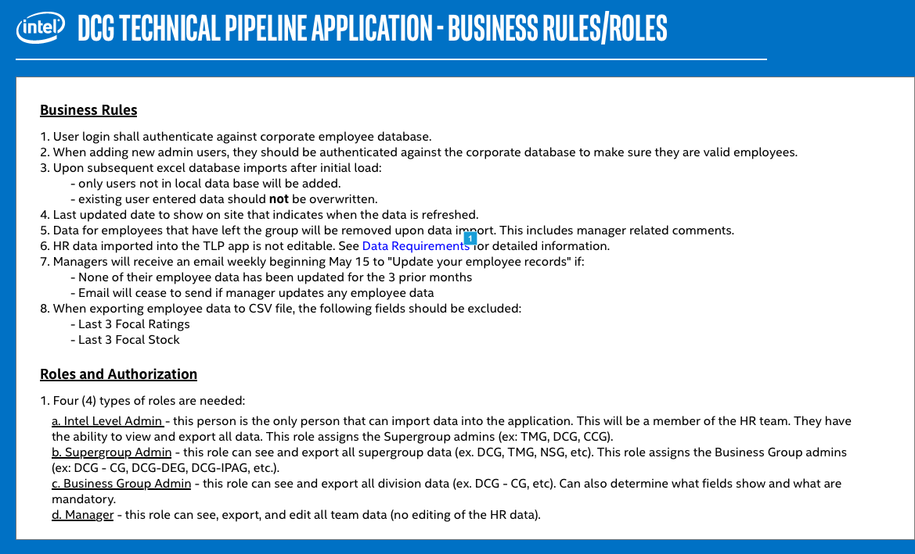

* + 1. Widget Table

| Footnote | Interactions |
| --- | --- |
| 1 | OnClick:  Case 1:  Open Data Requirements in Current Window |

* 1. Org Architecture Reference
     1. User Interface

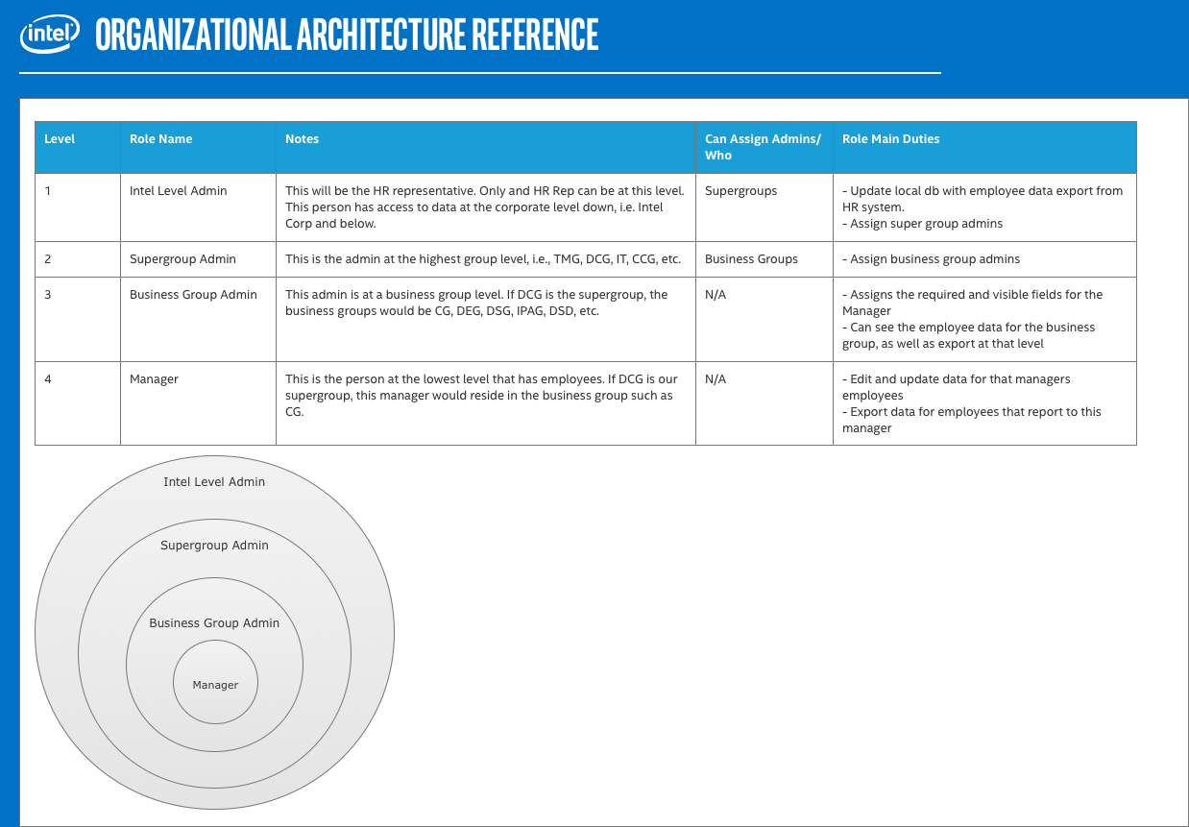

* 1. Login
     1. User Interface

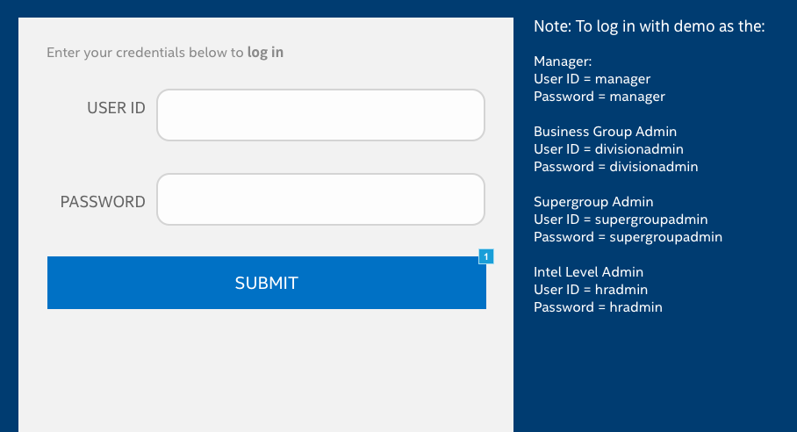

* + 1. Widget Table

| Footnote | Name | Interactions |
| --- | --- | --- |
| 1 | Submit button | OnClick:  Case 3  (If text on userID equals "" and text on Password equals ""):  Set Submit message to User ID and Password Error show if hidden  Wait 2000 ms  Hide Submit message  Case 4  (Else If text on userID equals "divisionadmin" and text on Password equals "divisionadmin"):  Set Submit message to Success show if hidden  Wait 2000 ms  Open Business Group Admin Home Page in Current Window  Case 5  (Else If text on userID equals "manager" and text on Password equals "manager"):  Set Submit message to Success show if hidden  Wait 2000 ms  Open Manager Home Page in Current Window  Case 5  (Else If text on userID equals "supergroupadmin" and text on Password equals "supergroupadmin"):  Set Submit message to Success show if hidden  Wait 2000 ms  Open Supergroup Admin Home Page in Current Window  Case 5  (Else If text on userID equals "hradmin" and text on Password equals "hradmin"):  Set Submit message to Success show if hidden  Wait 2000 ms  Open Intel Level Admin Home Page in Current Window |

* + 1. Submit message
       1. Success
       2. User Interface



* + - 1. User ID and Password Error
      2. User Interface



* + - 1. User ID Error
      2. User Interface



* + - 1. Password Error
      2. User Interface



* 1. Manager Home Page
     1. User Interface

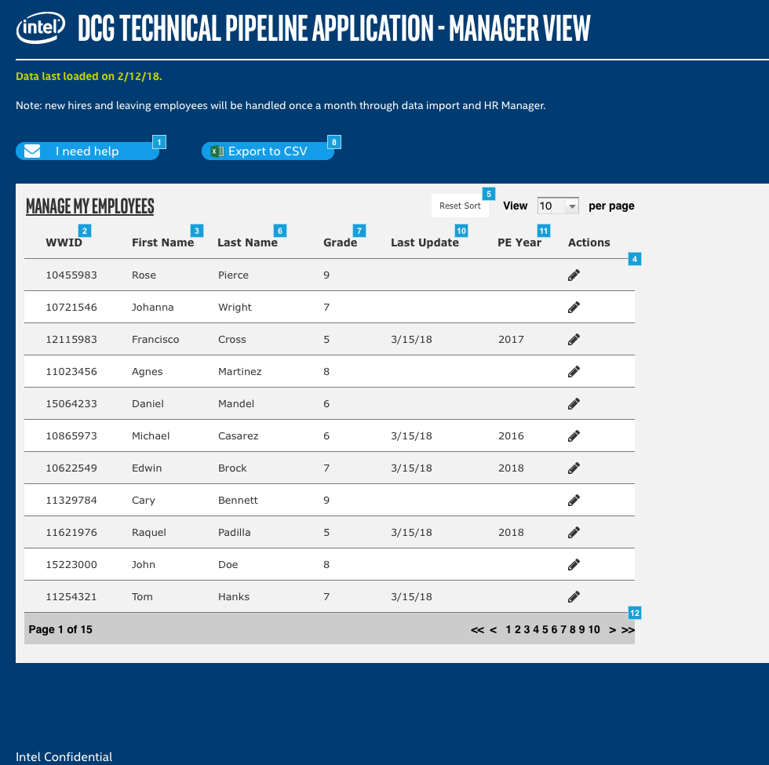

* + 1. Widget Table

| Footnote | Name | Interactions | Note |
| --- | --- | --- | --- |
| 1 |  | OnClick:  Case 1:  Open mailto:vikki.a.mueller.espinosa@intel.com@intel.com?Subject=I need help with the TLP App in Current Window | This button should open an email with subject Help with TLP Application and addressed to support team. |
| 2 | WWID Heading | OnClick:  Case 1:  Set is selected of This equal to "true"  Add Sort Name as Text toggle, default asc to Employees |  |
| 3 | First Name Heading | OnClick:  Case 1:  Set is selected of This equal to "true"  Add Sort Department as Text toggle, default asc to Employees |  |
| 4 | Employees | OnItemLoad:  Case 1:  Set text on PE_Year equal to "[[Item.PE_Year]]", and  text on Last_Update equal to "[[Item.Last_Update]]", and  text on Available equal to "[[Item.Grade]]", and  text on Hire Date equal to "[[Item.Last_Name]]", and  text on Department equal to "[[Item.First_Name]]", and  text on Name equal to "[[Item.WWID]]" |  |
| 5 | Remove Sort | OnClick:  Case 1:  Remove Sort All from Employees  Set is selected of First Name Heading equal to "false", and  is selected of WWID Heading equal to "false", and  is selected of Last Name Heading equal to "false", and  is selected of Grade Heading equal to "false", and  is selected of Last Update Heading equal to "false", and  is selected of PE Year Heading equal to "false" |  |
| 6 | Last Name Heading | OnClick:  Case 1:  Set is selected of This equal to "true"  Add Sort Available as Text toggle, default desc to Employees |  |
| 7 | Grade Heading | OnClick:  Case 1:  Set is selected of This equal to "true"  Add Sort Available as Text toggle, default desc to Employees |  |
| 8 |  | OnClick:  Case 1:  Show/Hide Widget | This button exports the employee data into a CSV file. |
| 9 |  | OnClick:  Case 1: |  |
| 10 | Last Update Heading | OnClick:  Case 1:  Set is selected of This equal to "true"  Add Sort Available as Text toggle, default desc to Employees |  |
| 11 | PE Year Heading | OnClick:  Case 1:  Set is selected of This equal to "true"  Add Sort Available as Text toggle, default desc to Employees |  |
| 12 | Page Header |  |  |

* + 1. Map lightbox
       1. State1
       2. User Interface

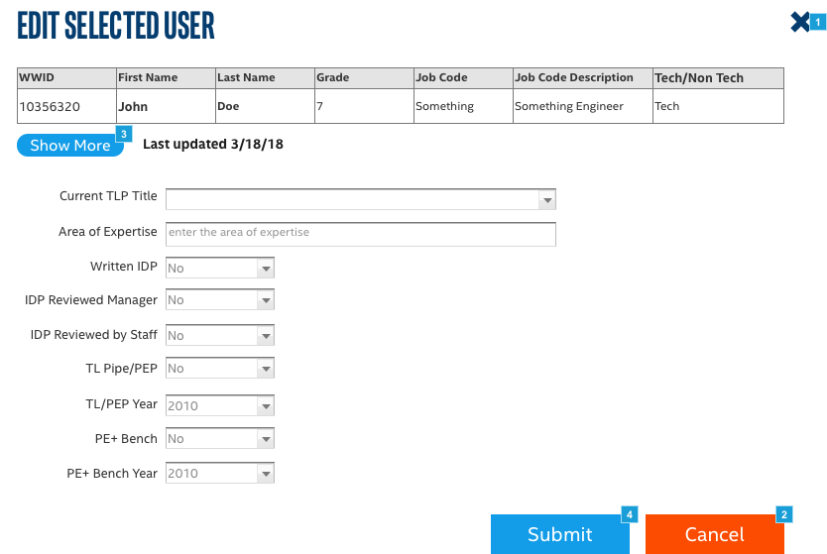

* + - 1. Widget Table

| Footnote | Name | Interactions |
| --- | --- | --- |
| 1 | Close button | OnClick:  Case 1:  Show pnl_Confirm fade 500 ms bring to front treat as lightbox |
| 2 |  | OnClick:  Case 1:  Show pnl_Confirm fade 500 ms bring to front treat as lightbox |
| 3 | btn_ToggleMore | OnClick:  Case 1  (If visibility of pnl_MoreDetails equals false):  Show pnl_MoreDetails fade 500 ms bring to front push widgets right linear 500ms  Set text on btn_ToggleMore equal to "Show Less"  Case 2  (Else If visibility of pnl_MoreDetails equals true):  Hide pnl_MoreDetails fade 500 ms pull widgets right linear 500ms  Set text on btn_ToggleMore equal to "Show More" |
| 4 |  | OnClick:  Case 1:  Show pnl_Save treat as lightbox  Wait 1500 ms  Hide pnl_Save, pnl_Confirm, Map lightbox |

* + 1. pnl_Confirm
       1. State1
       2. User Interface

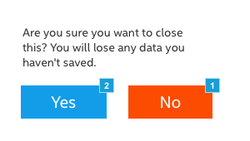

* + - 1. Widget Table

| Footnote | Interactions |
| --- | --- |
| 1 | OnClick:  Case 1:  Hide pnl_Confirm |
| 2 | OnClick:  Case 1:  Hide Map lightbox  Hide pnl_Confirm |

* + 1. pnl_MoreDetails
       1. State1
       2. User Interface

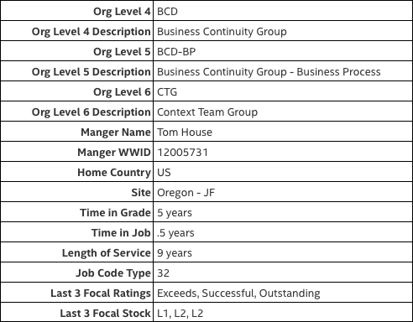

* + 1. pnl_Save
       1. State1
       2. User Interface

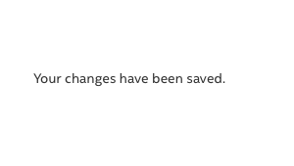

* + 1. Employees
       1. User Interface



* + - 1. Widget Table

| Footnote | Name | Interactions |
| --- | --- | --- |
| 1 | Edit Row | OnClick:  Case 1:  Show Map lightbox treat as lightbox  Set text on btn_ToggleMore equal to "Show More" |

* 1. Business Group Admin Home Page
     1. User Interface

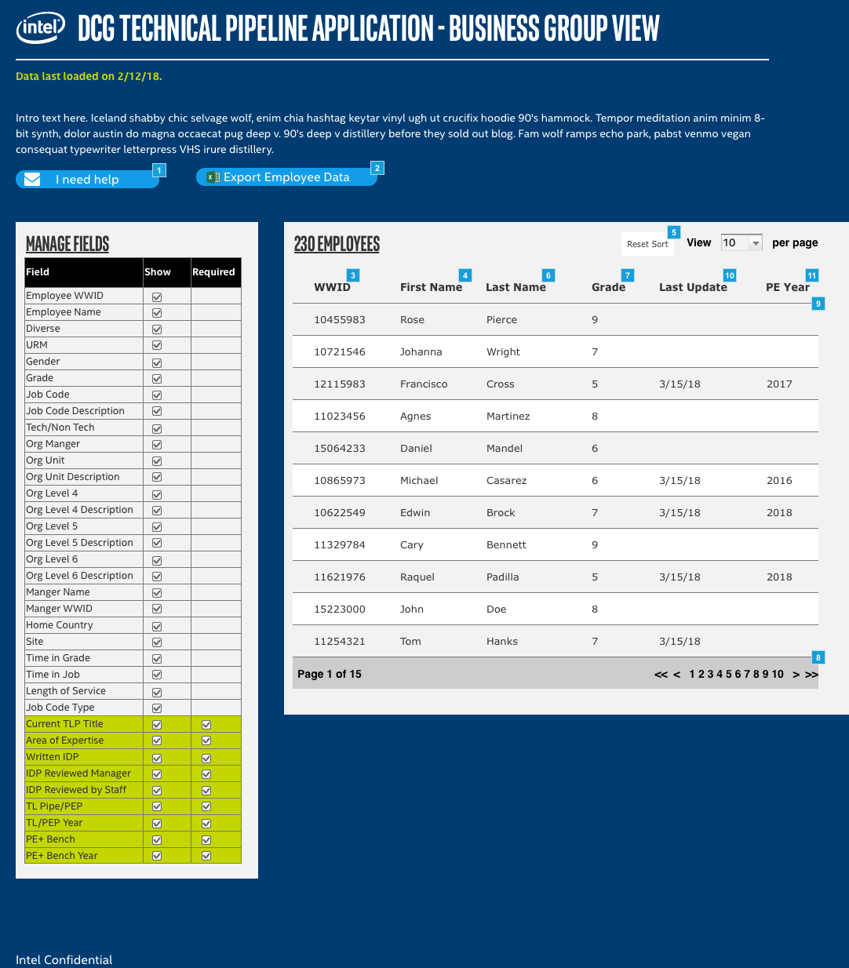

* + 1. Widget Table

| Footnote | Name | Interactions | Note |
| --- | --- | --- | --- |
| 1 |  | OnClick:  Case 1:  Open mailto:vikki.a.mueller.espinosa@intel.com@intel.com?Subject=I need help with the TLP App in Current Window | This button should open an email with subject Help with TLP Application and addressed to support team. |
| 2 |  |  | This button exports the employee data into a CSV file. |
| 3 | WWID Heading | OnClick:  Case 1:  Set is selected of This equal to "true"  Add Sort Available as Text toggle, default desc to Employees |  |
| 4 | First Name Heading | OnClick:  Case 1:  Set is selected of This equal to "true"  Add Sort Available as Text toggle, default desc to Employees |  |
| 5 | Remove Sort | OnClick:  Case 1:  Remove Sort All from Employees  Set is selected of First Name Heading equal to "false", and  is selected of WWID Heading equal to "false", and  is selected of Last Name Heading equal to "false", and  is selected of Grade Heading equal to "false", and  is selected of PE Year Heading equal to "false", and  is selected of Last Update Heading equal to "false" |  |
| 6 | Last Name Heading | OnClick:  Case 1:  Set is selected of This equal to "true"  Add Sort Available as Text toggle, default desc to Employees |  |
| 7 | Grade Heading | OnClick:  Case 1:  Set is selected of This equal to "true"  Add Sort Available as Text toggle, default desc to Employees |  |
| 8 | Page Header |  |  |
| 9 | Employees | OnItemLoad:  Case 1:  Set text on PE_Year equal to "[[Item.PE_Year]]", and  text on Last_Update equal to "[[Item.Last_Update]]", and  text on Available equal to "[[Item.Grade]]", and  text on Hire Date equal to "[[Item.Last_Name]]", and  text on Department equal to "[[Item.First_Name]]", and  text on Name equal to "[[Item.WWID]]" |  |
| 10 | Last Update Heading | OnClick:  Case 1:  Set is selected of This equal to "true"  Add Sort Available as Text toggle, default desc to Employees |  |
| 11 | PE Year Heading | OnClick:  Case 1:  Set is selected of This equal to "true"  Add Sort Available as Text toggle, default desc to Employees |  |

* + 1. Employees
       1. User Interface



* 1. Supergroup Admin Home Page
     1. User Interface

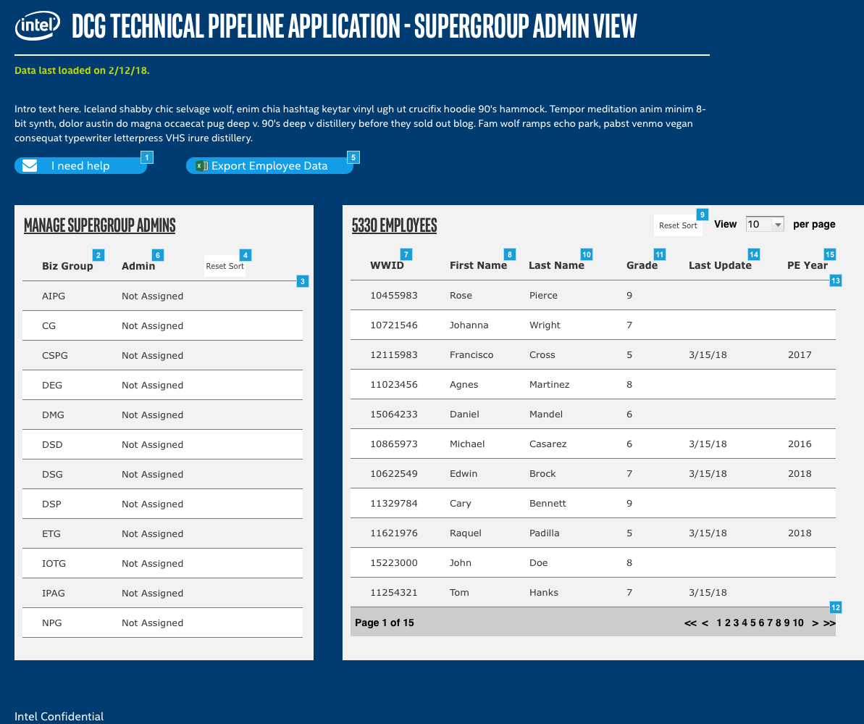

* + 1. Widget Table

| Footnote | Name | Interactions | Note |
| --- | --- | --- | --- |
| 1 |  | OnClick:  Case 1:  Open mailto:vikki.a.mueller.espinosa@intel.com@intel.com?Subject=I need help with the TLP App in Current Window | On first run, this button says "Help me build a strategy". After a strategy is created, this button should say "Update my strategy" |
| 2 | Biz Group Heading | OnClick:  Case 1:  Set is selected of This equal to "true"  Add Sort Biz_Group as Text toggle, default asc to Supergroup Admins |  |
| 3 | Supergroup Admins | OnItemLoad:  Case 1:  Set text on rect_AdminName equal to "[[Item.Admin_Name]]", and  text on rect_Biz Group equal to "[[Item.Biz_Group]]" |  |
| 4 | Remove Sort | OnClick:  Case 1:  Remove Sort All from Supergroup Admins  Set is selected of Biz Group Heading equal to "false", and  is selected of Admin Heading equal to "false" |  |
| 5 |  |  | This button exports the employee data into a CSV file. |
| 6 | Admin Heading | OnClick:  Case 1:  Set is selected of This equal to "true"  Add Sort Admin_Name as Text asc to Supergroup Admins |  |
| 7 | WWID Heading | OnClick:  Case 1:  Set is selected of This equal to "true"  Add Sort WWID as Number toggle, default asc to Employees |  |
| 8 | First Name Heading | OnClick:  Case 1:  Set is selected of This equal to "true"  Add Sort First_Name as Text toggle, default asc to Employees |  |
| 9 | Remove Sort | OnClick:  Case 1:  Remove Sort All from Employees  Set is selected of First Name Heading equal to "false", and  is selected of WWID Heading equal to "false", and  is selected of PE Year Heading equal to "false", and  is selected of Last Update Heading equal to "false", and  is selected of Grade Heading equal to "false", and  is selected of Last Name Heading equal to "false" |  |
| 10 | Last Name Heading | OnClick:  Case 1:  Set is selected of This equal to "true"  Add Sort Last_Name as Text toggle, default asc to Employees |  |
| 11 | Grade Heading | OnClick:  Case 1:  Set is selected of This equal to "true"  Add Sort Grade as Text toggle, default asc to Employees |  |
| 12 | Page Header |  |  |
| 13 | Employees | OnItemLoad:  Case 1:  Set text on PE_Year equal to "[[Item.PE_Year]]", and  text on Last_Update equal to "[[Item.Last_Update]]", and  text on Available equal to "[[Item.Grade]]", and  text on Hire Date equal to "[[Item.Last_Name]]", and  text on Department equal to "[[Item.First_Name]]", and  text on Name equal to "[[Item.WWID]]" |  |
| 14 | Last Update Heading | OnClick:  Case 1:  Set is selected of This equal to "true"  Add Sort Last_Update as Date - MM/DD/YYYY toggle, default asc to Employees |  |
| 15 | PE Year Heading | OnClick:  Case 1:  Set is selected of This equal to "true"  Add Sort PE_Year as Number toggle, default asc to Employees |  |

* + 1. Supergroup Admins
       1. User Interface



* + - 1. Widget Table

| Footnote | Name | Interactions |
| --- | --- | --- |
| 1 | Edit Row | OnClick:  Case 1:  Show Edit Group treat as lightbox |
| 2 | Edit Group | OnShow:  Case 1:  Set text on txt_Admin Name equal to text on rect_AdminName |
| 3 | Discard Edits | OnClick:  Case 1:  Hide Edit Group |
| 4 | Save Edits | OnClick:  Case 1:  Hide Edit Group  Update Rows Set None for This in Supergroup Admins  Set text on rect_AdminName equal to value of supergroupAdminName |
| 5 |  | OnLostFocus:  Case 1:  Set value of supergroupAdminName equal to selected option of This |

* + 1. Employees
       1. User Interface



* 1. Intel Level Admin Home Page
     1. User Interface

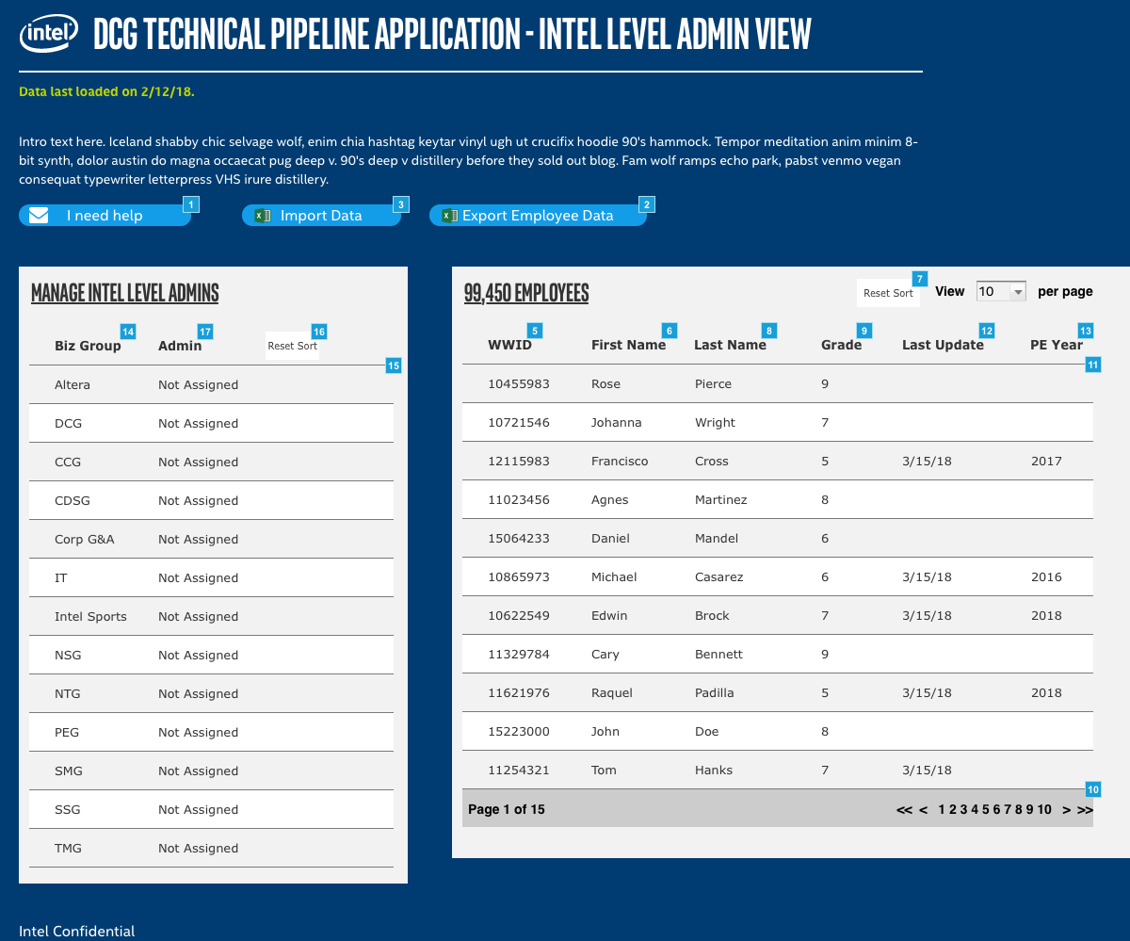

* + 1. Widget Table

| Footnote | Name | Interactions | Note |
| --- | --- | --- | --- |
| 1 |  | OnClick:  Case 1:  Open mailto:vikki.a.mueller.espinosa@intel.com@intel.com?Subject=I need help with the TLP App in Current Window | On first run, this button says "Help me build a strategy". After a strategy is created, this button should say "Update my strategy" |
| 2 |  |  | This button exports the employee data into a CSV file. |
| 3 |  | OnClick:  Case 1:  Show imgUploadDynPan treat as lightbox | This button exports the employee data into a CSV file. |
| 4 |  | OnClick:  Case 1: |  |
| 5 | WWID Heading | OnClick:  Case 1:  Set is selected of This equal to "true"  Add Sort WWID as Number toggle, default asc to Employees |  |
| 6 | First Name Heading | OnClick:  Case 1:  Set is selected of This equal to "true"  Add Sort First_Name as Text toggle, default desc to Employees |  |
| 7 | Remove Sort | OnClick:  Case 1:  Remove Sort All from Employees  Set is selected of WWID Heading equal to "false", and  is selected of First Name Heading equal to "false", and  is selected of Unidentified equal to "false", and  is selected of Unidentified equal to "false" |  |
| 8 | Last Name Heading | OnClick:  Case 1:  Set is selected of This equal to "true"  Add Sort Last_Name as Text toggle, default desc to Employees |  |
| 9 | Grade Heading | OnClick:  Case 1:  Set is selected of This equal to "true"  Add Sort Grade as Number toggle, default desc to Employees |  |
| 10 | Page Header |  |  |
| 11 | Employees | OnItemLoad:  Case 1:  Set text on PE_Year equal to "[[Item.PE_Year]]", and  text on Last_Update equal to "[[Item.Last_Update]]", and  text on Available equal to "[[Item.Grade]]", and  text on Hire Date equal to "[[Item.Last_Name]]", and  text on Department equal to "[[Item.First_Name]]", and  text on Name equal to "[[Item.WWID]]" |  |
| 12 | Last Update Heading | OnClick:  Case 1:  Set is selected of This equal to "true"  Add Sort Last_Update as Date - MM/DD/YYYY toggle, default desc to Employees |  |
| 13 | PE Year Heading | OnClick:  Case 1:  Set is selected of This equal to "true"  Add Sort PE_Year as Number toggle, default desc to Employees |  |
| 14 | Biz Group Heading | OnClick:  Case 1:  Set is selected of This equal to "true"  Add Sort Biz_Group as Text toggle, default asc to Intel Level Admins |  |
| 15 | Intel Level Admins | OnItemLoad:  Case 1:  Set text on rect_AdminName equal to "[[Item.Admin_Name]]", and  text on rect_Biz Group equal to "[[Item.Biz_Group]]" |  |
| 16 | Remove Sort | OnClick:  Case 1:  Remove Sort All from Intel Level Admins  Set is selected of Biz Group Heading equal to "false", and  is selected of Admin Heading equal to "false" |  |
| 17 | Admin Heading | OnClick:  Case 1:  Set is selected of This equal to "true"  Add Sort Admin_Name as Text toggle, default asc to Intel Level Admins |  |

* + 1. imgUploadDynPan
       1. State1
       2. User Interface

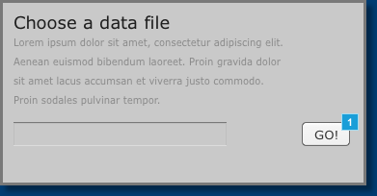

* + - 1. Widget Table

| Footnote | Interactions |
| --- | --- |
| 1 | OnClick:  Case 1:  Hide imgUploadDynPan |

* + 1. Employees
       1. User Interface



* + 1. Intel Level Admins
       1. User Interface



* + - 1. Widget Table

| Footnote | Name | Interactions |
| --- | --- | --- |
| 1 | Edit Row | OnClick:  Case 1:  Show Edit Group treat as lightbox |
| 2 | Edit Group | OnShow:  Case 1:  Set text on txt_Admin Name equal to text on rect_AdminName |
| 3 | Discard Edits | OnClick:  Case 1:  Hide Edit Group |
| 4 | Save Edits | OnClick:  Case 1:  Hide Edit Group  Update Rows Set None for This in Intel Level Admins  Set text on rect_AdminName equal to value of supergroupAdminName |
| 5 |  | OnLostFocus:  Case 1:  Set value of supergroupAdminName equal to selected option of This |